***Name:Bijapure Naheen***

***R.No:08***

***ISE-I***

***Q1.***

***<!DOCTYPE html>***

***<html>***

***<head>***

***<title>Circle Using Canvas</title>***

***<style>***

***canvas{***

***width=300px;***

***height=150;***

***border:1px solid #000000;***

***margin-left:350px;***

***margin-top:200px;***

***}***

***</style>***

***</head>***

***<body>***

***<canvas id="myCan1">***

***Your browser does not support the HTML5 canvas tag.</canvas>***

***<script>***

***var c = document.getElementById("myCan1");***

***var ctx = c.getContext("2d");***

***ctx.beginPath();***

***ctx.arc(100, 75, 50, 0, 2 * Math.PI);***

***ctx.stroke();***

***ctx.font = "15px Arial";***

***ctx.fillText("Hello World",63,80);***

***</script>***

***</body>***

***</html>***

***Output:***

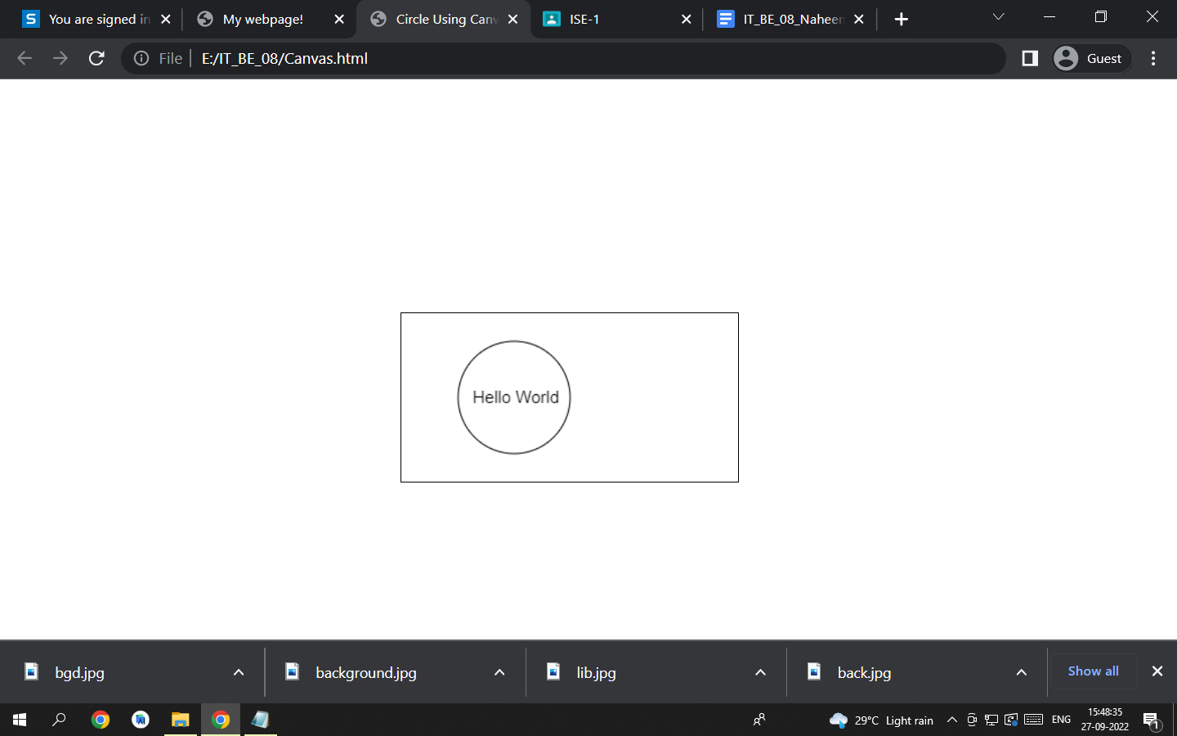

***Q2.***

*<html>*

*<head>*

*<title>My webpage!</title>*

*<link rel="stylesheets" href="styles.css">*

*<style>*

*h1{*

*color:#B83E24;*

*}*

*div{*

*position:relative;*

*left:450px;*

*top:150px;*

*}*

*</style>*

*</head>*

*<body style="background-image:url('bgd.jpg');">*

*<h1 style="text-align:center">Welcome to the library Of WIT Solapur</h1>*

*<div>*

*<details>*

*<summary style="color:#7324B8">Here's a list of books in our library!</summary>*

*<ul>*

*<li>The Art of Zen - Alan Watts</li>*

*<li>The Jungle Book - That one guy</li>*

*<li>I Am America and So Can You! - S. Colbert</li>*

*<li>Wings Of Fire - A.P.J Abdul Kalam</li>*

*<li>All Acadmic Books</li>*

*<li>Adventures of Tom Sawyer: Mark Twain & many more</li>*

*</ul>*

*</details>*

*<br>*

*<details>*

*<summary style="color:#7324B8">Details</summary>*

*<p>Library of WIT is known for its richest collection of books and journals. It is one of the best libraries in the region. The library functions from 8.00 a.m. to 8.00 p.m. on all working days. All the books have been classified as per Dewey Decimal classification and are available for open access.Collection: WIT Library provides services & facilities to the requirements of the Institutionals teaching & research programmes. It has an excellent collection of reference books prescribed by Solapur University; with handbooks of Intel, Motorola and National Semiconductor devices. The collection includes the following: Books Reference Sources- Dictionaries, Encyclopedias, Handbooks Journals/ Periodicals (Print format): National & International domains E-Journals (IEEE, ASME, ASE, ScienceDirect) Bound Archives of old Periodicals. Magazines / Newsletters / Newspapers Data Manuals- Motorola, Intel, National Semiconductor, etc CDs, VCDs, DVDs, etc.The library is structured in three sections: Issue Section, Reference Section, Reading Hall Section: The Issue Section has a vast collection of Text Books for the needs of WIT students and faculty. Reference Section: The Reference Section has a vast collection of rare reference books, National and International periodicals, Data Manuals, Handbooks, Encylopedias, Project & Seminar Reports, CDs., VCDs, etc. Reading Hall: The Reading Hall has a capacity to accommodate around 265 students at a time. Xeroxing facility is also available during the working hours.We have developed our Library meticulously and there are 56625 Volumes of 21700 titles worth Rs 1.88 Lacs. During the current academic year, 1055 books, 163 titles worth Rs 4,93,048 have been added. Besides this we have subscribed 77 National & International journals along with 542 e-journals including Science Direct, ASME, ASE, IEEE worth Rs 19.07 Lacs. Additionally, departmental Libraries have 1072 volumes and 899 titles, along with this we have established a Digital Library facility with 14 systems for the students.The library has 1428 e-books titles and volumes. We have purchased VCD and course material from British Institutes for the students over all development for business communication. Also we have purchased entrepreneurship development CD’s. To avail the facility of advanced journals & rare books, our institute has taken the institutional membership of IIT Bombay.*

*</p>*

*</details>*

*</div>*

*</body>*

*</html>*

***Output:***

